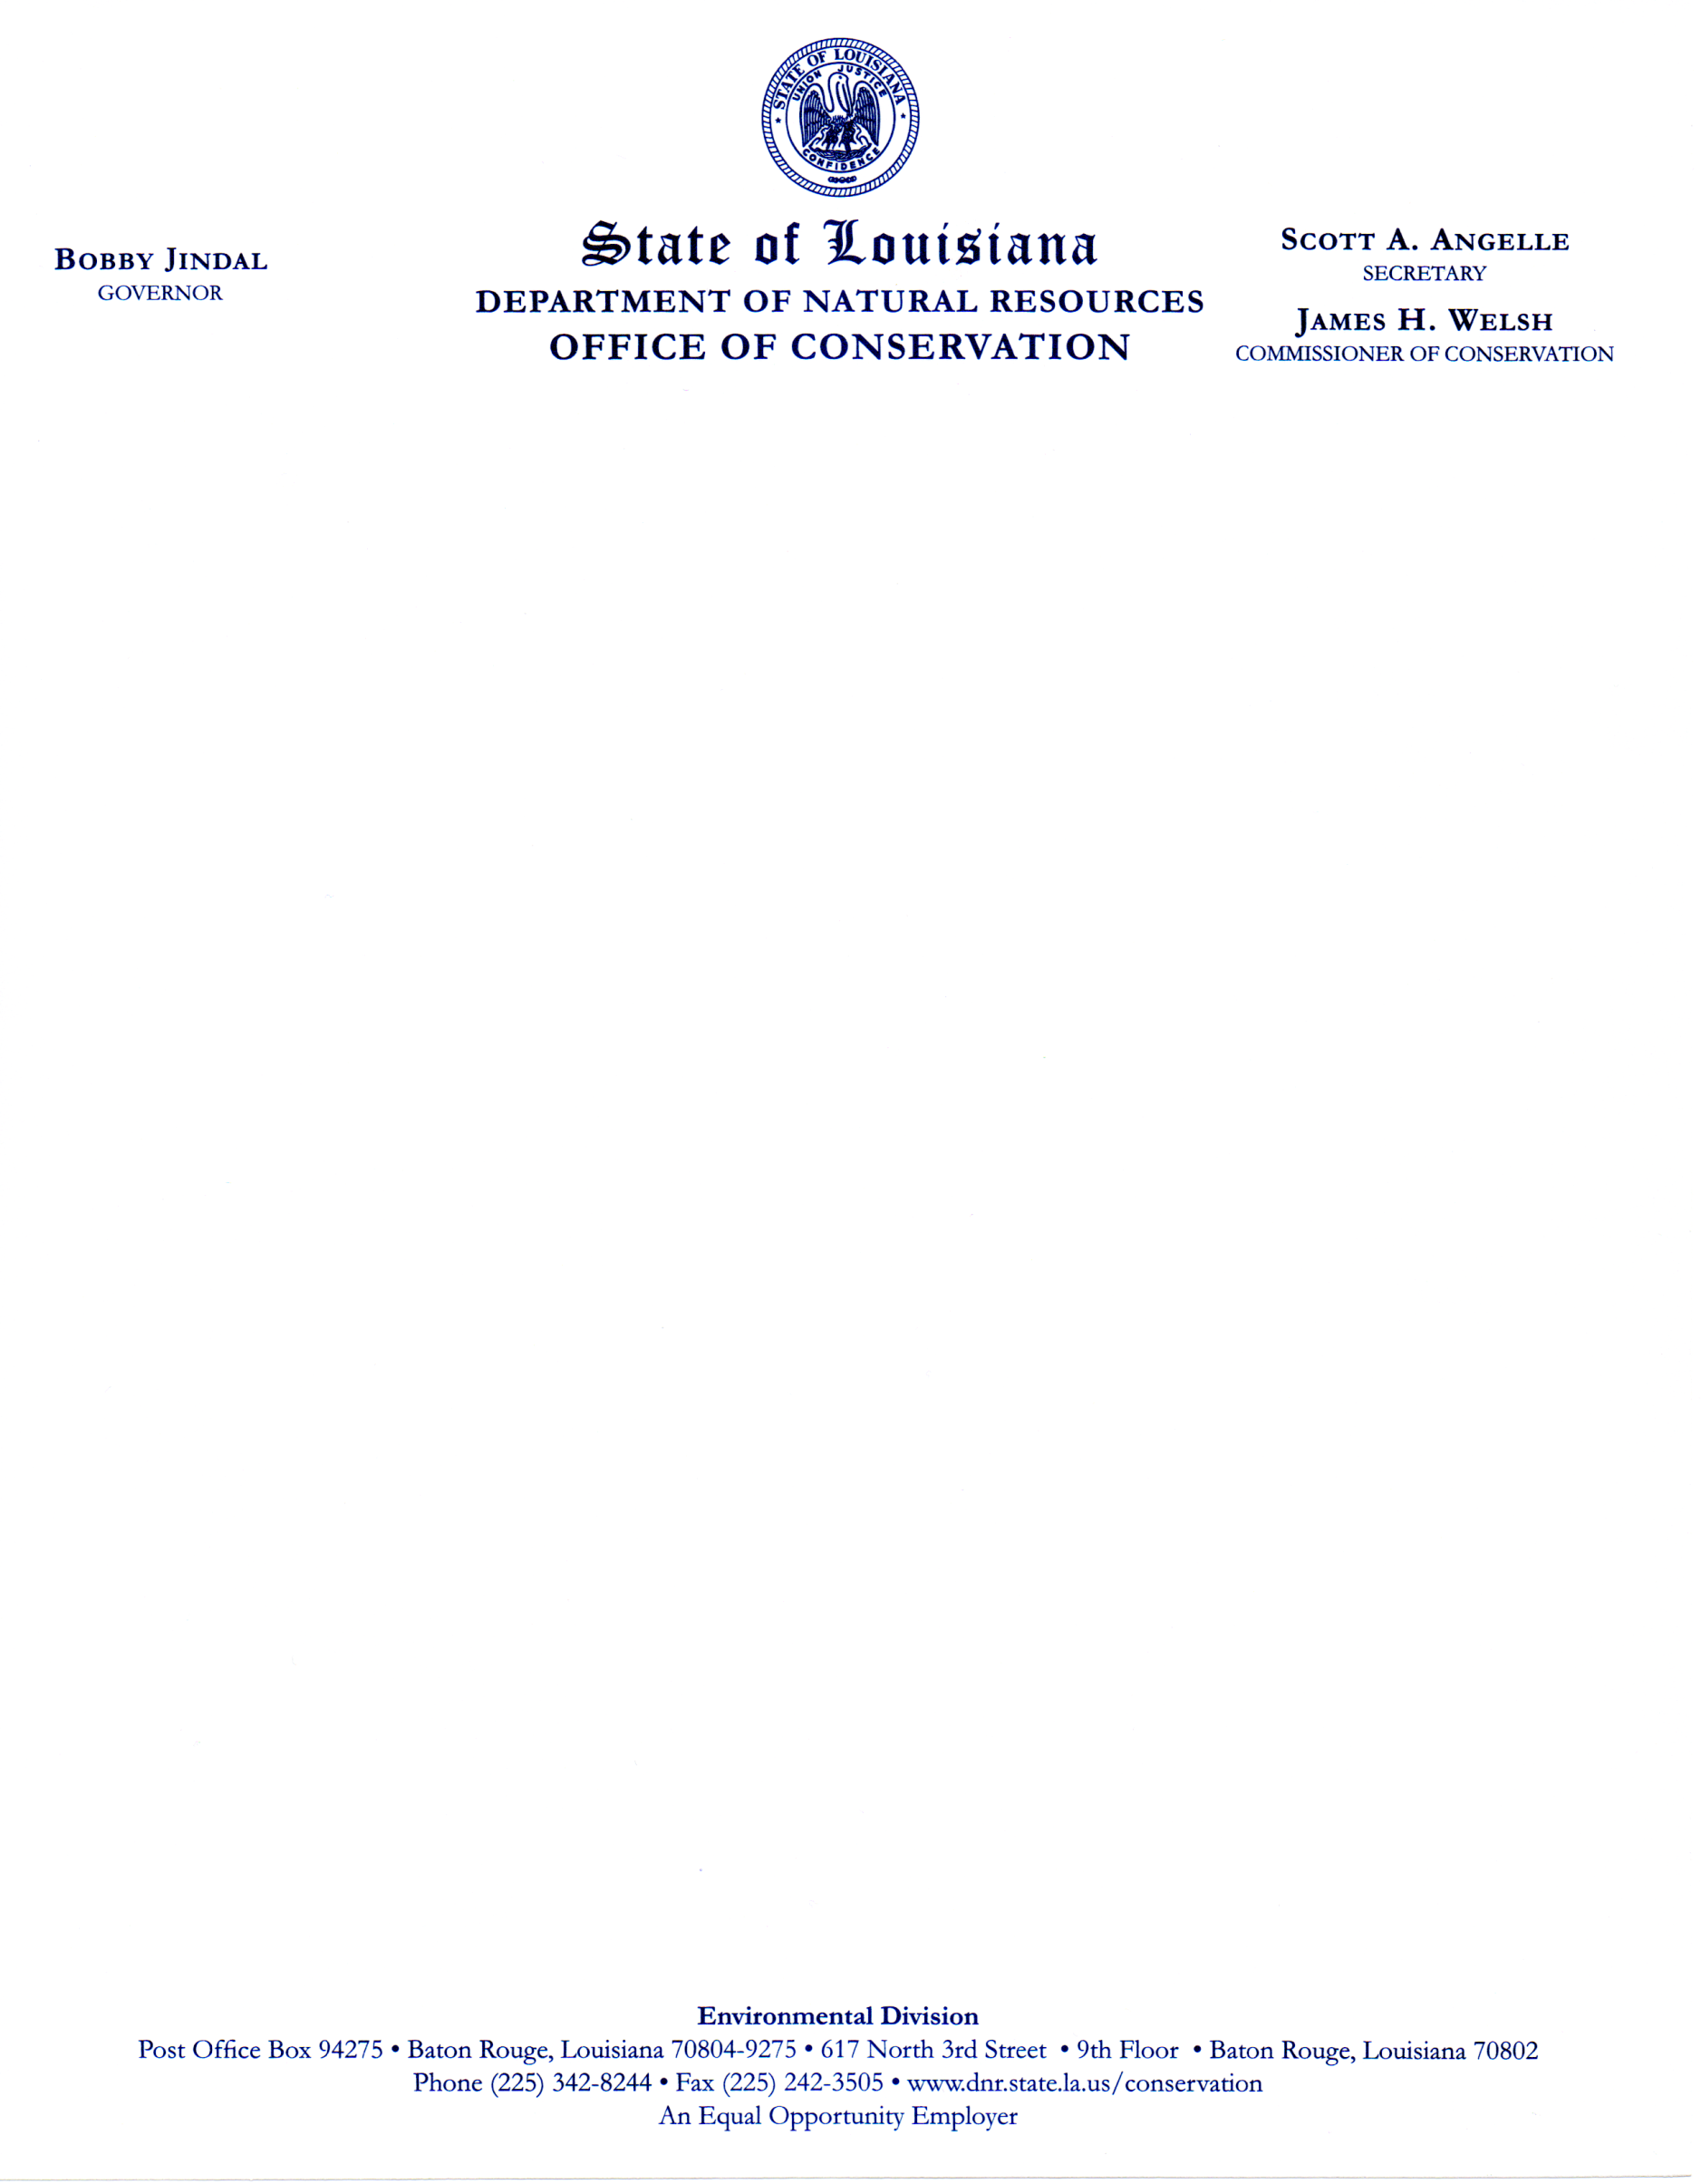

**Meeting Notice**

**The Ground Water Resources Commission will conduct its**

**15th Regular Meeting**

**Wednesday, February 3, 2010**

**11:00 A.M.**

**Louisiana State Exhibit Museum**

**3015 Greenwood Road**

**Shreveport, Louisiana 71109**